Brooklyn US Judge Rules NY Law Examiners Must Obey Federal Law for Persons With Disabilities

A federal judge in the U.S. District Court for the Eastern District of New York has ruled that the state's board of law examiners is subject to a federal law banning discrimination on the basis of disability from any program or activity receiving federal funding.
By Jane Wester | September 18, 2019 at 05:47 PM
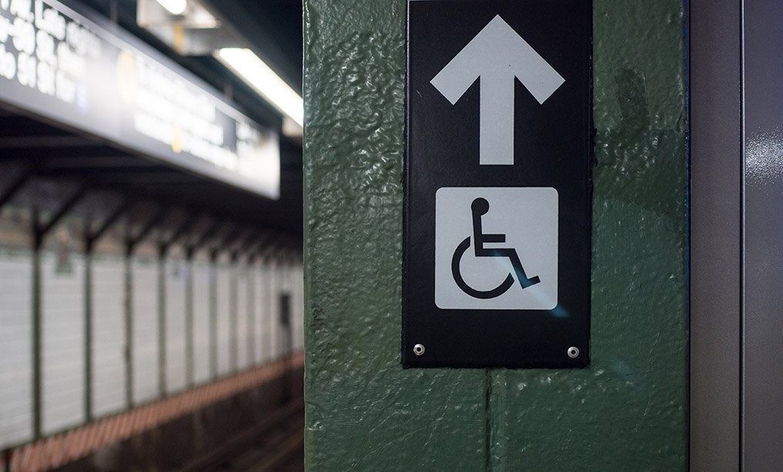
Disabled elevator sign on a subway platform. Photo: Shutterstock
A federal judge in the U.S. District Court for the Eastern District of New York has ruled that the state’s board of law examiners, which administrates the New York bar exam, is subject to a federal law banning discrimination on the basis of disability from any program or activity receiving federal funding.
The order Wednesday from U.S. District Judge Raymond Dearie of the Eastern District of New York denied a motion to dismiss from the board and clarified the board’s obligations toward people seeking accommodations for disabilities as they take the bar exam.
Section 504 of the Rehabilitation Act of 1973 applies to the board, Dearie ruled, because it is a “program or activity” of the state’s Unified Courts System, which receives federal funding.
Dearie found that the complaint made out a case that the board discriminated against the plaintiff, who is identified by her initials T.W. in court documents, by denying her full accommodations the first two times she took the bar exam, in 2013 and 2014. She failed both times and lost her job at a respected law firm as a result, her attorney Jo Anne Simon said.
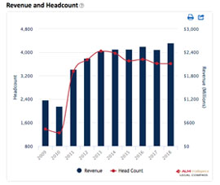
The third time T.W. sat for the bar exam, she didn’t provide any more evidence about her needs, but she was finally granted the right accommodations and passed, Simon said.
“(But) once you’re out of the loop, you’re derailed from the big law firms,” Simon said.
In 1998, the U.S. Court of Appeals for the Second Circuit ruled that the board was subject to Section 504 because it accepted state vouchers for certain bar exam and registration fees, and the vouchers came from agencies receiving federal funds. But in 2011—partly in response to the 1998 decision, Dearie wrote—the board stopped accepting vouchers, and the agencies began reimbursing bar candidates for their fees instead.
Simon argued that the reimbursement meant the board still received federal funds. Dearie disagreed, but he also found that that didn’t matter for Section 504.
No matter what vouchers the board takes or doesn’t take, Dearie ruled, its financial and administrative relationship with the Unified Courts System means that it is a program or entity of the system under Section 504.
The Board of Law Examiners’ executive director, John McAlary, did not immediately respond to a request for comment.
https://www.law.com/newyorklawjournal/2019/09/18/brooklyn-us-judge-rules-ny-law-examiners-must-obey-federal-law-for-persons-with-disabilities/

